SECOND YEAR MINI PROJECT REPORT

Submitted in partial fulfillment of the requirements of

the degree

BACHELOR OF ENGINEERING IN

COMPUTER ENGINEERING


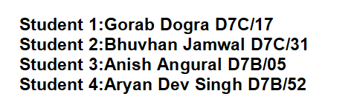

Name of the Mentor
Mrs. PRITI JOSHI
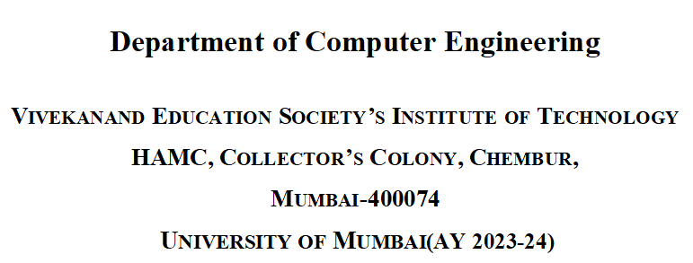
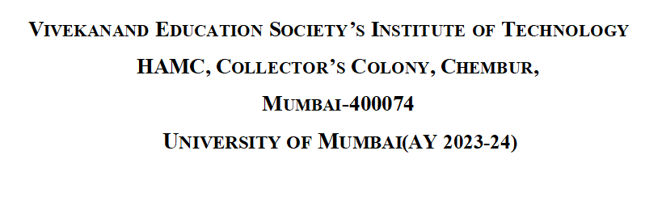

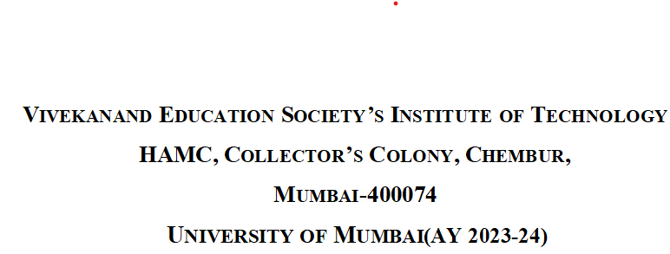

CERTIFICATE

This is to certify that the Mini Project entitled “ Restaurant Booking Website

” is a bonafide work of Gorab Dogra(17), Bhuvhan Jamwal(31), Anish Angural(5),Aryan Dev Singh(52) submitted to the University of Mumbai in partial fulfillment of the requirement for the award of the degree of “Bachelor

of Engineering” in “Computer Engineering” .

(Prof. Priti Joshi)

Supervisor

(DR.Nupur Giri)

(DR.J.M Nair)
Head of Department

Principal

Mini Project Approval

This is to certify that the Mini Project entitled “RESTAURANT BOOKING WEBSITE”

is a bonafide work of Gorab dogra(17), Bhuvhan jamwal(31), anish angural(05),

Aryan dev singh(52) submitted to the University of Mumbai in partial fulfillment of the

requirement for the award of the degree of “Bachelor of Engineering” in “Computer

Engineering” .

Examiners

1………………………………………

(Internal Examiner Name & Sign)

2…………………………………………

(External Examiner name & Sign)

Date:
Place:

Contents

Abstract

Acknowledgments

1 | Introduction | 4
1.1 | Introduction
1.2 | Motivation
1.3 | Problem Statement & Objectives
2 | Literature Survey | 10
2.1 | Survey of Existing System
2.2 | Limitation Existing system or research gap
2.3 | Mini Project Contribution
3 | Proposed System | 13
3.1 | Introduction
3.2 | Framework
3.3 | Algorithm
3.4 | Details of Hardware & Software
3.4 | Experiment and Results
3.5 | 
3.6 | Conclusion and Future work.


References | 24

Abstract:

The project is based on a website that can be used by customers to book the desired table and menu of their choice from a restaurant as per their convenience.

Restaurants used to reserve tables manually, a practice that is gradually disappearing from well-known establishments. However, in the modern era, customers are increasingly utilising digital reservations, and providers are contemplating the adoption of digital booking systems.

There is no automated method for maintaining the records in the manual system; instead, everything is dependent on the waiter and booking journal.

The main goal is to create a table and menu reservation system that will help staff members with fundamental problems with their manual reservation method. For instance, how money and time are used.

In addition to serving consumers, the project caters to the needs of restaurant owners by

offering robust backend management tools. Through this system, restaurants can efficiently manage their profiles, update menus, adjust availability, and engage with customer feedback, thereby optimizing operations and fostering customer satisfaction.

Ultimately, the Restaurant Booking Website project endeavors to elevate the dining experience for all stakeholders involved, leveraging technology to facilitate seamless

interactions between diners and establishments while fostering a culture of convenience,

efficiency, and personalized service in the culinary landscape.

Acknowledgments:

We would like to express our most sincere appreciation to all the individuals who have helped and supported us throughout this project. We are thankful to our project mentor Mrs. Priti Joshi, for her ongoing support during the project and a special acknowledgment goes to the project department who gave us an opportunity to do this wonderful project.

In addition, we would like to thank our parents for their support and interest, who inspired us and encouraged us to follow our own path. Without them,this project would not have been possible. In the end, we want to thank our friends who displayed appreciation for our work and motivated us to continue our work.

We convey our deep sense of gratitude to all teaching and non-teaching staff for their constant encouragement, support and selfless help throughout the project work. It is a great pleasure to acknowledge the help and suggestion, which we received from the Department of Computer Engineering.

We wish to express our profound thanks to all those who helped us in gathering information about the project. Our families too have provided moral support and encouragement several times.

1.Introduction

1.1 Introduction

- In the era of increasingly rapid technological development, the human need for primary goods is increasing.

- Initial problem is that the customer has to get connected over the phone, it would be harder if the restaurant is very popular and busy .

- The higher demand triggers the accumulation of processes in distribution to consumers or what is called a queue.

- The queuing phenomenon above arises because of limited services and the need for these services is very high.

- This problem can trigger boredom from consumers because of long queue times, including food service such as in restaurants.

- As a primary need, the process of obtaining food commodities in the form of food requires quick and easy time in today's fast-paced era.

- Most restaurants have a single phone line and a single operator to handle incoming calls, so they can accept limited orders.

1.2 Motivation:

Online Access:

Let us start with what we consider an essential benefit that you can gain from a restaurant booking website. customers can now find restaurant online through a website. With the website, customers have the option to make a reservation without having to make a call or physically head to your restaurant.

Reservation Management:

With the help of a restaurant booking website, you can accurately monitor your restaurant’s capacity. This will help you ensure that you handle overbooking and do not exceed the allowed seating capacity.

Attracts new customers:

Every restaurant wants to grow and the only way to do is to attract new customers.

Using an online restaurant reservation system can take you one step closer to that goal.

Predict wait times:

Using a restaurant booking system can help you predict wait times and turnaround tables faster.
1.3 Problem statement and Objectives

Problem Statement

a. Initial problem is that the customer has to get connected over the phone , it would be harder if the restaurant is very popular and busy.

b. As the customer won’t have the menu list with him, it would be harder for him to remember the entire list (with price as well...!) and come to a decision, i.e. the customer is provided with less time to make a decision.

c. The chances of committing mistakes at the restaurant side in providing a menu list for a specific time would be more.

d. There might be some communication problems or sometimes language might be a barrier.

Objective

- This research is to develop an online restaurant booking website that allows the customer to directly interact with the restaurant’s staff about their needs and order.

- By providing this reservation website, the restaurant and customers will get to optimize food online reservation and booking experience.

- The major goal of this task is to enable the owner of a restaurant to deal directly with the clients.

- In addition, it can place client's requests to discover free tables as indicated by their own need of particular required number of seats in his choice area.
LITERATURE SURVEY

S | Paper name | Issue | Methodology | Conclusion | Limitation
NO | and it’s | Date
 | Author
1) | REVIEW |  | It delves into | In conclusion, | Accessibility
 | PAPER ON |  | the significance | while restaurant | Issues: Not
 | RESTAURANT | (2022) | of online | reservation and | all
 | RESERVATIO |  | reservation | management | customers
 | N AND |  | platforms, | systems offer | have access
 | MANAGEMEN |  | mobile apps, | numerous | to or are
 | T |  | and their impact | benefits such | comfortable
 |  |  | on streamlining | as efficiency | using online
 |  |  | the booking | and customer | reservation
 |  |  | process. | satisfaction, | platforms or
 | AUTHOR- |  | Additionally, it | they also pose | mobile
 | AJAY |  | discusses the | challenges | apps,
 | AGGARWAL, |  | importance of | including | limiting the
 | PRIYA SINGH |  | customer | accessibility | reach of the
 |  |  | relationship | issues, | restaurant's
 |  |  |  | technical | reservation
 |  |  |  | glitches, and | system.
 |  |  |  | data privacy
 |  |  |  | concerns.
2) | TABLE |  | Collect correct | It utilizes | Systems
 | BOOKING | (2023) | and precise | Tensorflow | cannot work
 | AND |  | data. | technology to | in various
 | RESTAURANT |  | Using Keras | recognize sign | lighting and
 | MANAGEMEN |  | library, | language and | background
 | T SYSTEM |  | convolution | the python and | conditions.
 | USING |  | layers was | OopenCVCV | Range of
 | ANDROID |  | implemented | were used for | dataset is
 | APPLICATION( |  |  | data | used s not
 | OPSS) |  |  | acquisition. | much.
 | AUTHOR-B.
 | NAVEEN
 | KUMAR,
 | B. SAI VARUN

3) | LITERATURE | (2022) | The | In conclusion, | Limitations
 | REVIEW ON |  | methodology | the review | may include
 | RESTAURANT |  | involves | highlights the | the
 | MANAGEMEN |  | conducting a | significance of | availability
 | T SYSTEM |  | systematic | Android-based | of
 |  |  | review of | table booking | comprehens
 |  |  | existing | and restaurant | ive data on
 |  |  | literature and | management | all existing
 |  |  | Android | systems in | Android-
 |  |  | applications | enhancing | based
 | AUTHOR- |  | related to table | operational | restaurant
 | PRATIK |  | booking and | efficiency and | managemen
 | LANKE, |  | restaurant | customer | t systems,
 | ANUJ SAPKAL |  | management | experience | potential
 |  |  | systems |  | biases in
 |  |  |  |  | user reviews
 |  |  |  |  | or feedback
4) | ONLINE |  | The literature | n conclusion, a | The
 | TABLE AND | (2021) | review on | comprehensive | limitations of
 | MENU |  | restaurant | literature review | restaurant
 | BOOKING |  | management | on restaurant | managemen
 | SYSTEM FOR |  | systems | management | t systems
 | RESTAURANT |  | encompasses | systems | encompass
 | S |  | various | underscores | various
 |  |  | methodologies | their pivotal role | aspects,
 |  |  | aimed at | in modernizing | including
 |  |  | enhancing | and enhancing | technical
 |  |  | efficiency, | operational | constraints,
 | AUTHOR- |  | customer | efficiency within | user
 | PARTH GOTI, |  | satisfaction, and | the hospitality | interface
 | SHARYU |  | operational | industry. By | challenges,
 | KALE |  | effectiveness | integrating | and
 |  |  | within the food | advanced | operational
 |  |  | service industry. | technology and | shortcoming
 |  |  | Research | features such | s. Firstly,
 |  |  | predominantly | as inventory | many
 |  |  | focuses on the | management, | systems
 |  |  | integration of | table | may lack
 |  |  | technology, | reservations, | seamless
 |  |  | such as point- | and customer | integration
 |  |  | of-sale (POS) | relationship | with existing
 |  |  | systems. | management. | hardware or
 |  |  |  |  | software .

2.2 Limitation Existing System and Research Gap:

Limited Restaurant Selection: Many online restaurant booking systems only include a subset of restaurants, which means users may not find their preferred or local restaurants on the platform.

Geographic Coverage: Some platforms may not cover all geographic areas, making it challenging for users to book restaurants in certain locations.

Limited Availability: Restaurants may not always keep their online booking systems up-to-date with their actual availability, leading to overbooking or disappointment for users.

Reservation Accuracy: While online booking systems aim to provide accurate reservation times, discrepancies can occur due to issues like table turnover times, kitchen delays, or unforeseen events.

User Experience: The user interface and experience of some online booking systems may not be user-friendly or intuitive, potentially frustrating users.

2.3 Mini Project Contribution:

Roll NO./Division | Team Member’s | Roles and
 | Name | Responsibilities
17/D7C | Gorab Dogra | Maintain log book
 |  | Prepare reports and
 |  | presentations
 |  | Write code
31/D7C | Bhuvhan | Perform testing
 | Jamwal | Prepare reports and
 | Jamwal | presentations
 |  | Debug code
5/D7B | Anish Angural | Maintain log book
 |  | Prepare reports and
 |  | presentations
 |  | Debug code
52/D7B | Aryan Dev Singh | Perform testing
 |  | Prepare reports and
 |  | presentations
 |  | Write code

3. Proposed System

3.1 Introduction

The Online Restaurant booking website system is developed to provide service facilities to restaurants and also to the customer.

This restaurant website can be used by employees in a restaurant to handle the clients, their orders and can help them easily find free tables or place orders.

The services that are provided are food ordering and reservation table management by the customer through the system online, customer information management and waiter information management, menu information management and report.

The web application of this system is used to maintain restaurant data such as membership maintenance and menu maintenance, manage reservation, perform food ordering, payment, kitchen maintenance and reporting.

3.2 Framework

Restaurant booking system framework:

1. Homepage:

Include a prominent logo, navigation menu and search bar. Showcase featured restaurants with high-quality images.

2. Restaurant Listing:

Display restaurant listings as cards with restaurant name, image, ratings, and a brief description.

Clicking on a listing should lead to a detailed page with extensive information about the restaurant, including menus, pricing, reviews, and images.

3. Instant Booking:

Instantly book any restaurant by clicking on Book Now option on main menu in home page.

4. 24/7 Online Booking:

The website is available 24/7 so that the users can choose any preferred time depending on the availability of the restaurants.

3.3 Algorithm:
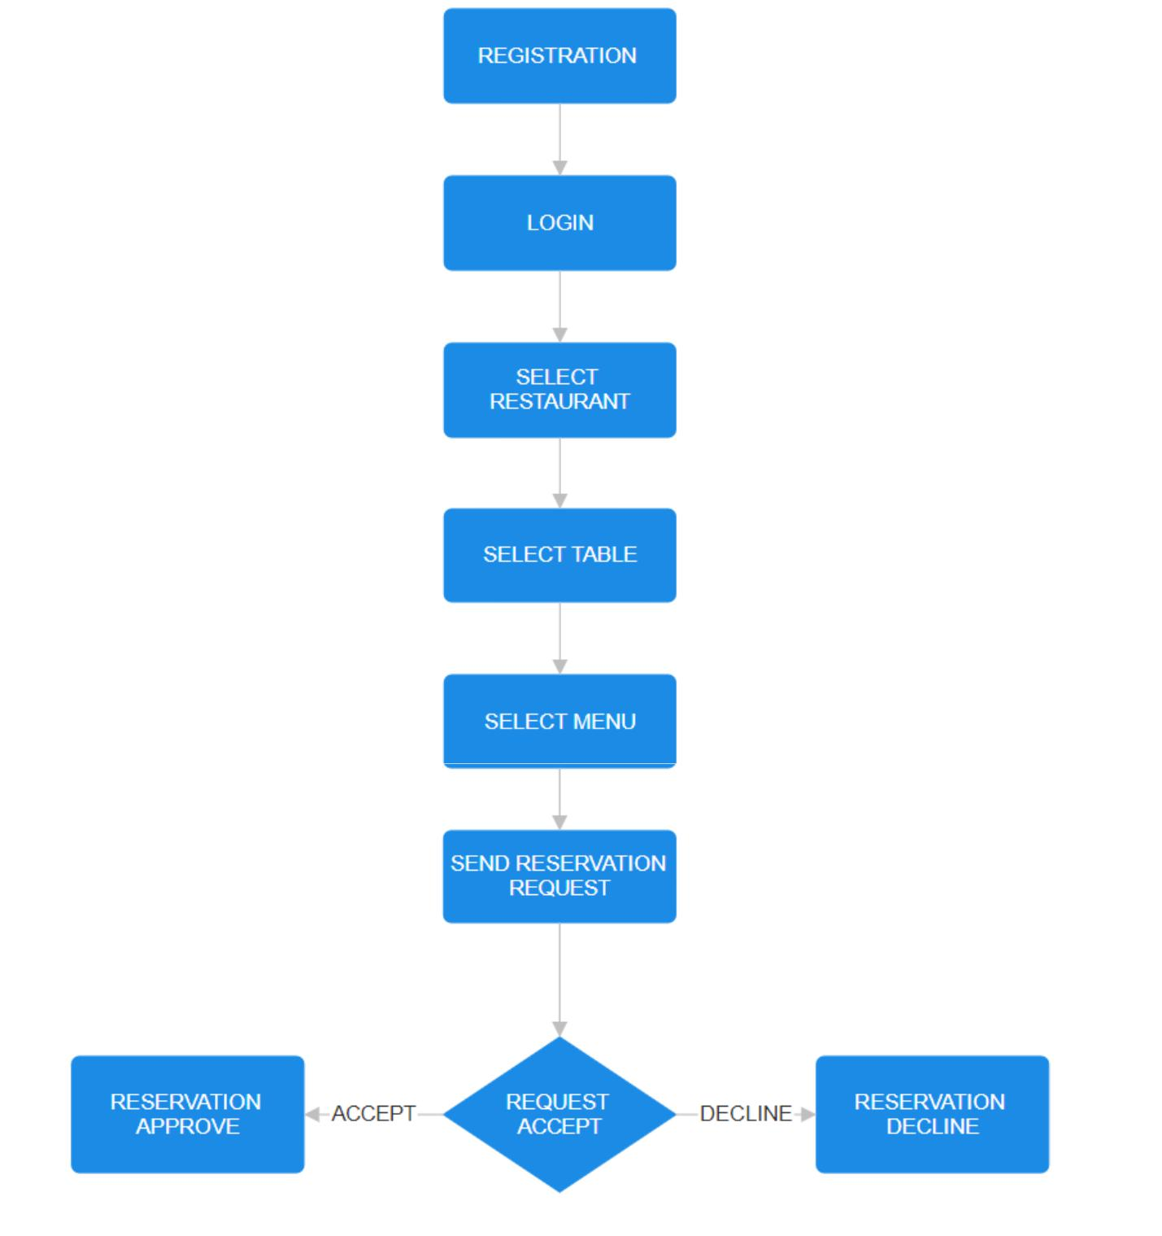

3.4 Details of Hardware and Software:

Hardware:

- RAM

- Compatible Processor

- Monitor

➢Internet Connection

Software:

➢VS Code

➢Windows 7 or higher

➢Google Chrome

Tools:

➢HTML

➢CSS

➢PHP

➢Java Script
3.5 Experiment and Results:
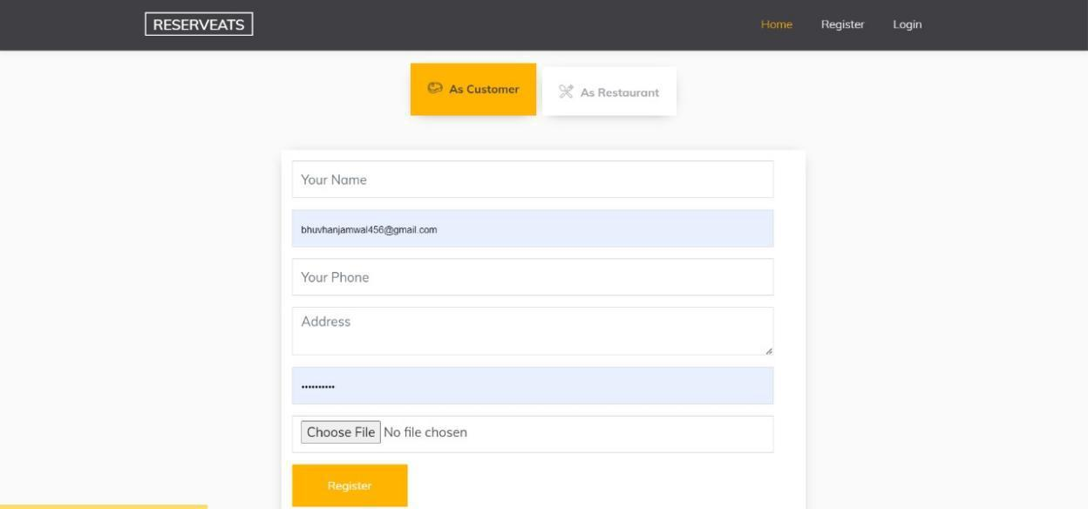

REGISTRATION PAGE
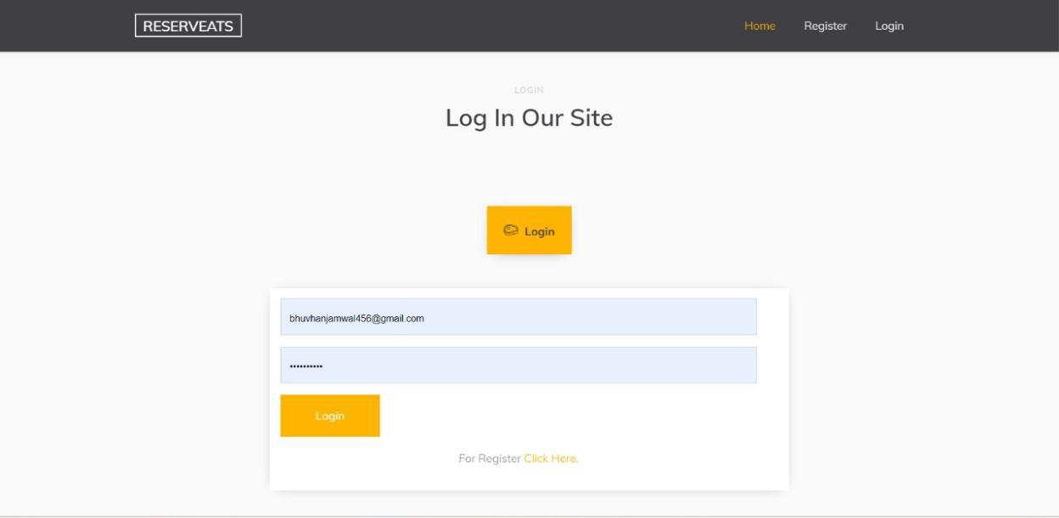

Fig(1)

LOGIN PAGE

FIG(2)

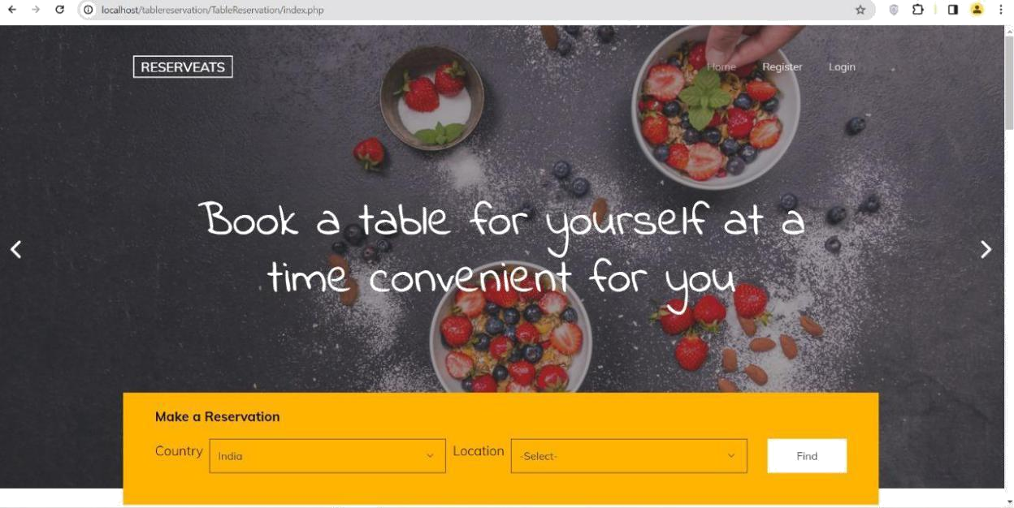

CHOOSE A LOCATION
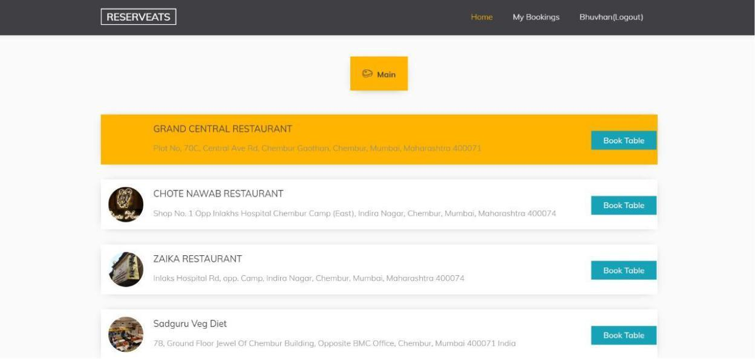

FIG(3)

CHOOSE A RESTAURANT

FIG(4)
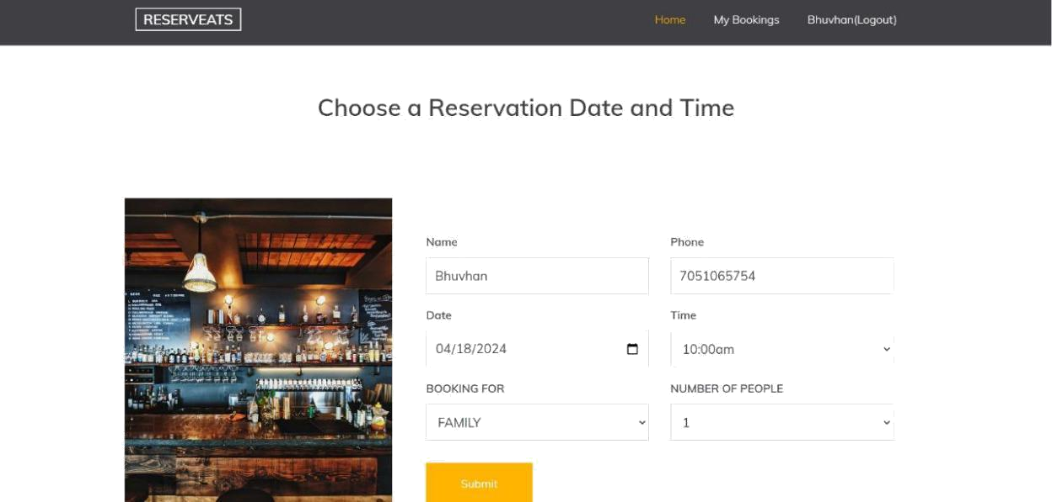

CHOOSE A RESERVATION TIME AND DATE
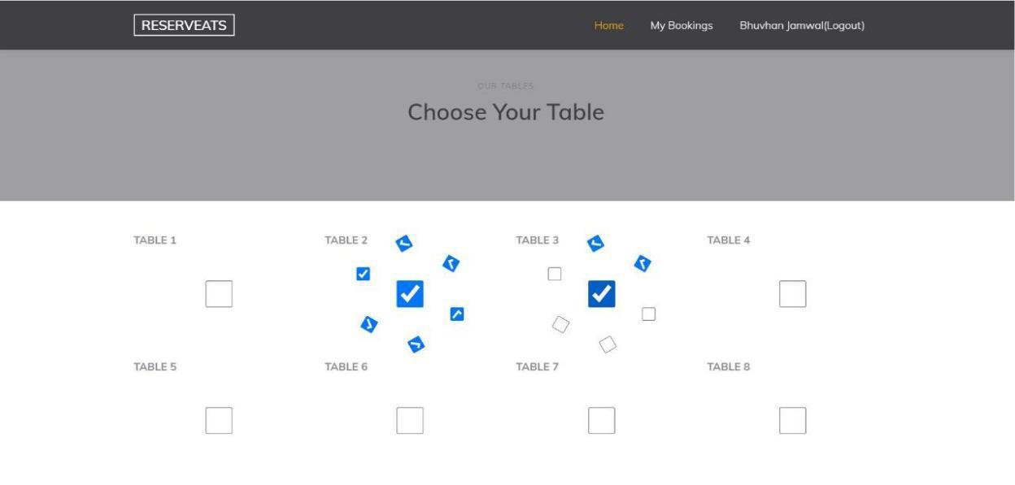

FIG(5)

CHOOSE A TABLE

FIG(6)

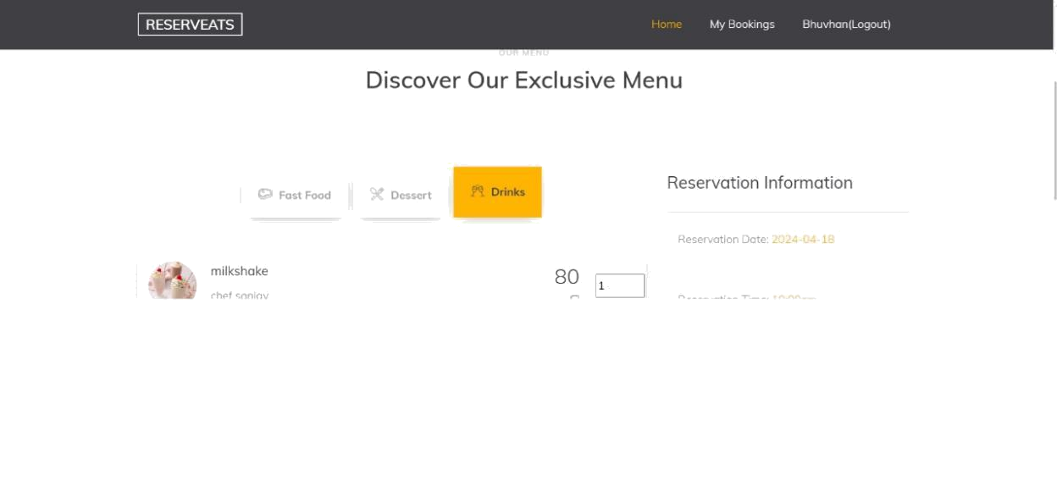

CHOOSE A MENU
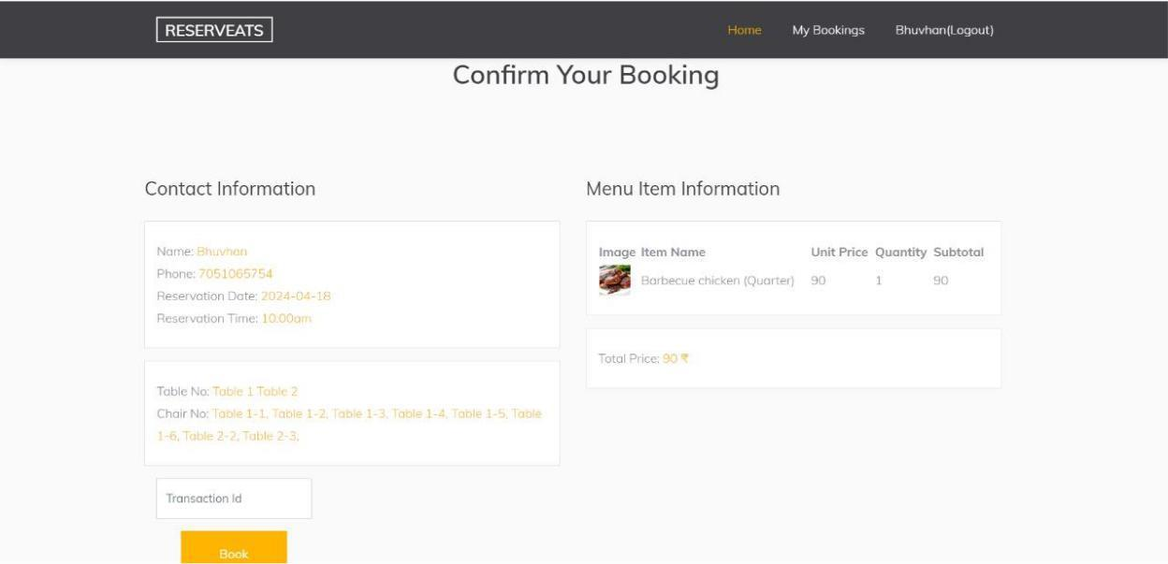
FIG(7)

TRANSACTION ID
FIG(8)
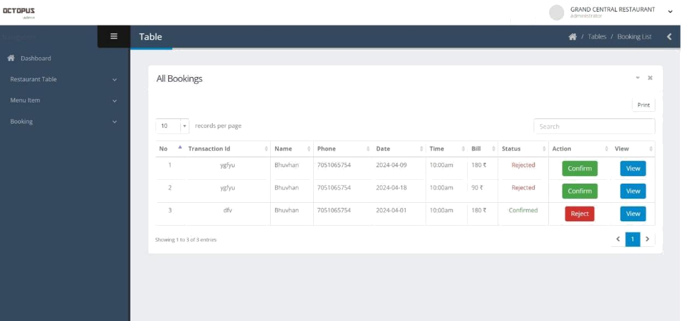

RESTAURANT’S APPROVAL OR DISAPPROVAL
FIG(9)
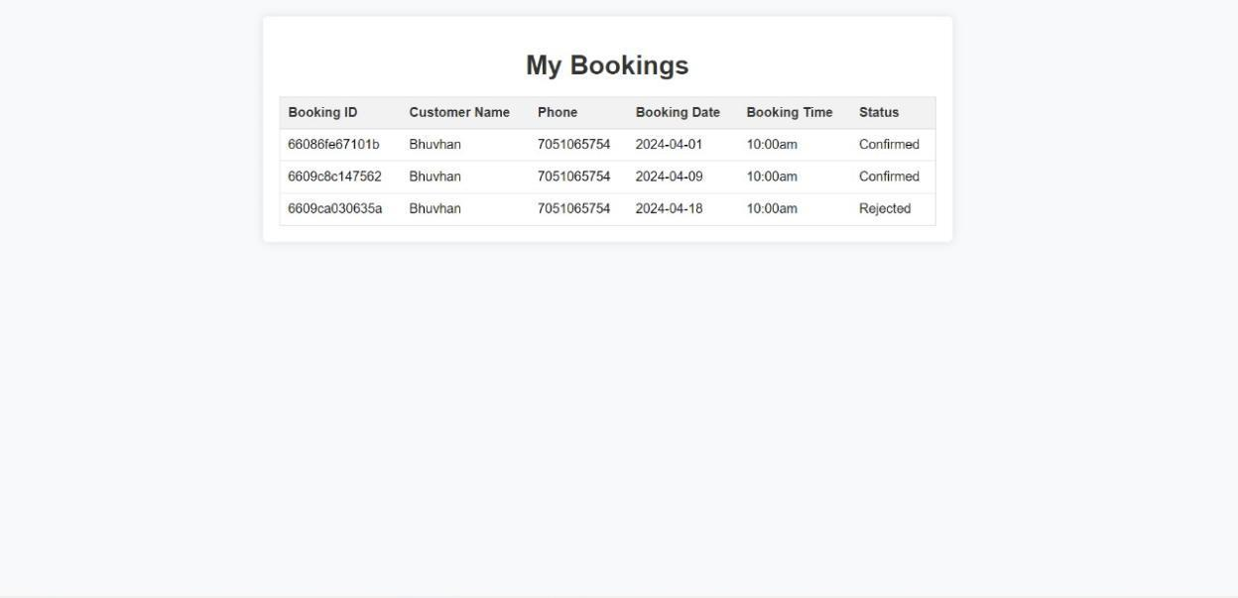
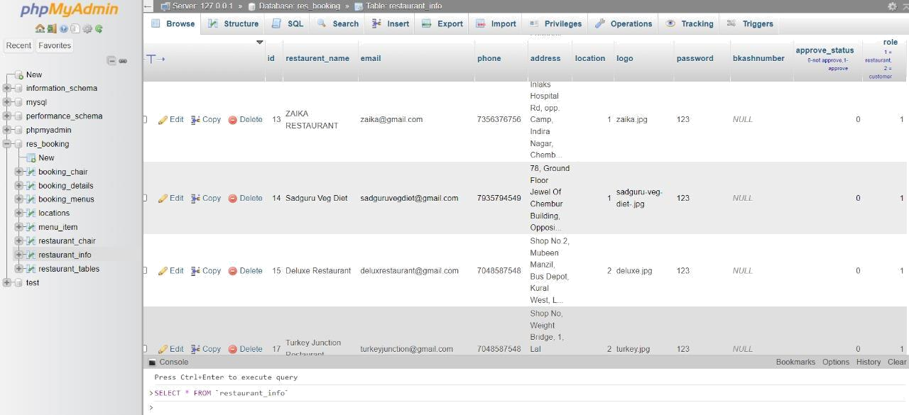

DATABASE TABLES
FIG(10)
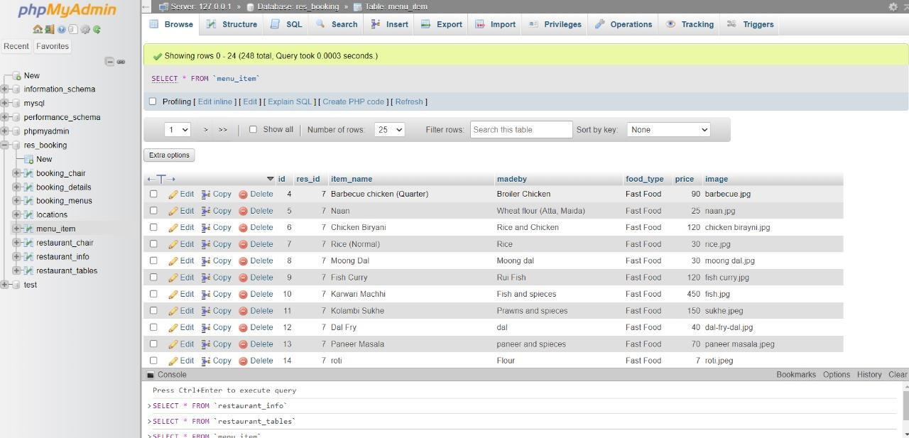
SA
3.6 Conclusion

The user or customer enters the credentials required to login the application.

After which the desired table number according to the customer’s convenience is selected. If required the menu is also booked in advance . Payment can also be done in advance but it's the user’s choice . Afterward the user can go to the restaurant at the selected time and can have his desired food without any tension of large lines or waiting time.In this , we have done the literature survey along with reading different newspaper reports Our aim is building a website to reduce manual work of the restaurant staff.

Making a system which is easy to use to all kind of people.In this , we have done the literature survey along with reading different newspaper reports .
References

1) Online Restaurant Booking Website.

https://www.ijprems.com/uploadedfiles/paper//issue_5_may_2022/243/final/fin _ ijprems1657462250.pdf

2) Online Table and Menu Booking System for Restaurants.

https://www.researchgate.net/publication/353753942_Online_Table_and_Menu _Booking_System_for_Restaurants

- The Website-Based Food Booking System Equipped with Real-Time Booking Status to Address Queuing Issues at Restaurants

https://ieeexplore.ieee.org/abstract/document/9587443

- A 'democratization of markets? Online consumer reviews in the restaurant industry.

https://sciencespo.hal.science/hal-02947884

